INTRODUCTION

When you turn on your computer, it's nice to think that you're in control. There's the trusty computer mouse, which you can move anywhere on the screen, summoning up your music library or Internet browser at the slightest whim. Although it's easy to feel like a director in front of your desktop or laptop, there's a lot going on inside, and the real man behind the curtain handling the necessary tasks is the operating system.
Most desktop or laptop PCs come pre-loaded with Microsoft Windows. Macintosh computers come pre-loaded with Mac OS X. Many corporate servers use the Linux or UNIX operating systems. The operating system (OS) is the first thing loaded onto the computer -- without the operating system, a computer is useless.

More recently, operating systems have started to pop up in smaller computers as well. If you like to tinker with electronic devices, you're probably pleased that operating systems can now be found on many of the devices we use every day, from cell phones to wireless access points. The computers used in these little devices have gotten so powerful that they can now actually run an operating system and applications. The computer in a typical modern cell phone is now more powerful than a desktop computer from 10 years ago, so this progression makes sense and is a natural development.

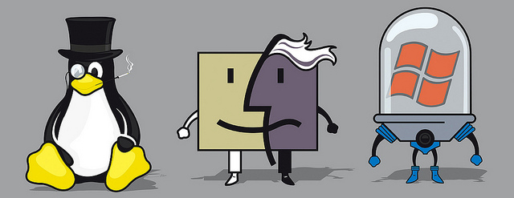
The three prime operating systems
The purpose of an operating system is to organize and control hardware and software so that the device it lives in behaves in a flexible but predictable way. In this report, we'll tell you what a piece of software must do to be called an operating system, show you how the operating system in your desktop computer works and give you some examples of how to take control of the other operating systems around you.
WHAT IS AN OPERATING SYSTEM?

Not all computers have operating systems. The computer that controls the microwave oven in your kitchen, for example, doesn't need an operating system. It has one set of tasks to perform, very straightforward input to expect (a numbered keypad and a few pre-set buttons) and simple, never-changing hardware to control. For a computer like this, an operating system would be unnecessary baggage, driving up the development and manufacturing costs significantly and adding complexity where none is required. Instead, the computer in a microwave oven simply runs a single hard-wired program all the time.

For other devices, an operating system creates the ability to:
- serve a variety of purposes
- interact with users in more complicated ways
- keep up with needs that change over time

All desktop computers have operating systems. The most common are the Windows family of operating systems developed by Microsoft, the Macintosh operating systems developed by Apple and the UNIX family of operating systems (which have been developed by a whole history of individuals, corporations and collaborators). There are hundreds of other operating systems available for special-purpose applications, including specializations for mainframes, robotics, manufacturing, real-time control systems and so on.

In any device that has an operating system, there's usually a way to make changes to how the device works. This is far from a happy accident; one of the reasons operating systems are made out of portable code rather than permanent physical circuits is so that they can be changed or modified without having to scrap the whole device.
For a desktop computer user, this means you can add a new security update, system patch, new application or even an entirely new operating system rather than junk your computer and start again with a new one when you need to make a change. As long as you understand how an operating system works and how to get at it, in many cases you can change some of the ways it behaves. The same thing goes for your phone, too.

Regardless of what device an operating system runs, what exactly can it do? Let us see that in the next section.

OPERATING SYSTEM FUNCTIONS

At the simplest level, an operating system does two things:
- It manages the hardware and software resources of the system. In a desktop computer, these resources include such things as the processor, memory, disk space and more (On a cell phone, they include the keypad, the screen, the address book, the phone dialer, the battery and the network connection).
- It provides a stable, consistent way for applications to deal with the hardware without having to know all the details of the hardware.
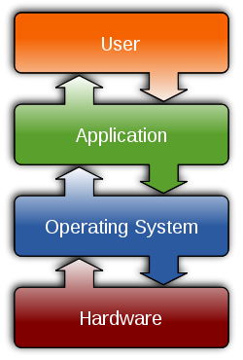
The first task, managing the hardware and software resources, is very important, as various programs and input methods compete for the attention of the central processing unit (CPU) and demand memory, storage I/O bandwidth for their own purposes. In this capacity, the operating system plays the role of the good parent, making sure that each application gets the necessary resources while playing nicely with all the other applications, as well as husbanding the limited capacity of the system to the greatest good of all the users and applications.
Interactions of Operating System

The second task, providing a consistent application interface, is especially important if there is to be more than one of a particular type of computer using the operating system, or if the hardware making up the computer is ever open to change. A consistent application program interface (API) allows a software developer to write an application on one computer and have a high level of confidence that it will run on another computer of the same type.
Even if a particular computer is unique, an operating system can ensure that applications continue to run when hardware upgrades and updates occur. This is because the operating system -- not the application -- is charged with managing the hardware and the distribution of its resources. One of the challenges facing developers is keeping their operating systems flexible enough to run hardware from the thousands of vendors manufacturing computer equipment. Today's systems can accommodate thousands of different printers, disk drives and special peripherals in any possible combination.
TYPES OF OPERATING SYSTEMS

Within the broad family of operating systems, there are generally four types, categorized based on the types of computers they control and the sort of applications they support. The categories are:
- Real-time operating system (RTOS) - Real-time operating systems are used to control machinery, scientific instruments and industrial systems. An RTOS typically has very little user-interface capability, and no end-user utilities, since the system will be a "sealed box" when delivered for use. A very important part of an RTOS is managing the resources of the computer so that a particular operation executes in precisely the same amount of time, every time it occurs. In a complex machine, having a part move more quickly just because system resources are available may be just as catastrophic as having it not move at all because the system is busy.
- Single-user, single task - As the name implies, this operating system is designed to manage the computer so that one user can effectively do one thing at a time. The Palm OS for Palm handheld computers is a good example of a modern single-user, single-task operating system.
- Single-user, multi-tasking - This is the type of operating system most people use on their desktop and laptop computers today. Microsoft's Windows and Apple's Mac OS platforms are both examples of operating systems that will let a single user have several programs in operation at the same time. For example, it's entirely possible for a Windows user to be writing a note in a word processor while downloading a file from the Internet while printing the text of an e-mail message.
- Multi-user - A multi-user operating system allows many different users to take advantage of the computer's resources simultaneously. The operating system must make sure that the requirements of the various users are balanced, and that each of the programs they are using has sufficient and separate resources so that a problem with one user doesn't affect the entire community of users. UNIX, VMS and mainframe operating systems, such as MVS, are examples of multi-user operating systems.
It's important to differentiate between multi-user operating systems and single-user operating systems that support networking. Windows 2000 and Novell Netware can each support hundreds or thousands of networked users, but the operating systems themselves aren't true multi-user operating systems. The system administrator is the only "user" for Windows 2000 or Netware. The network support and all of the remote user logins the network enables are, in the overall plan of the operating system, a program being run by the administrative user.

CLASSIFICATION OF OPERATING SYSTEMS

Based on Control Set and Application Types

Based on Architecture and Targeted Devices

COMPUTER OPERATING SYSTEMS

When you turn on the power to a computer, the first program that runs is usually a set of instructions kept in the computer's read-only memory (ROM). This code examines the system hardware to make sure everything is functioning properly. This power-on self test (POST) checks the CPU, memory, and basic input-output systems (BIOS) for errors and stores the result in a special memory location. Once the POST has successfully completed, the software loaded in ROM (sometimes called the BIOS or firmware) will begin to activate the computer's disk drives. In most modern computers, when the computer activates the hard disk drive, it finds the first piece of the operating system- the bootstrap loader.

The bootstrap loader is a small program that has a single function: It loads the operating system into memory and allows it to begin operation. In the most basic form, the bootstrap loader sets up the small driver programs that interface with and control the various hardware subsystems of the computer. It sets up the divisions of memory that hold the operating system, user information and applications. It establishes the data structures that will hold the myriad signals, flags and semaphores that are used to communicate within and between the subsystems and applications of the computer. Then it turns control of the computer over to the operating system.

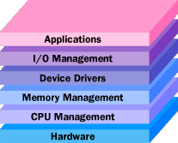
The operating system's tasks, in the most general sense, fall into six categories:

- Processor management
- Memory management
- Device management
- Storage management
- Application interface
- User interface
Tasks of Operating System

While there are some who argue that an operating system should do more than these six tasks, and some operating-system vendors do build many more utility programs and auxiliary functions into their operating systems, these six tasks define the core of nearly all operating systems. Next, let's look into the world of Desktop Operating System and study its timeline.

DESKTOP OPERATING SYSTEMS
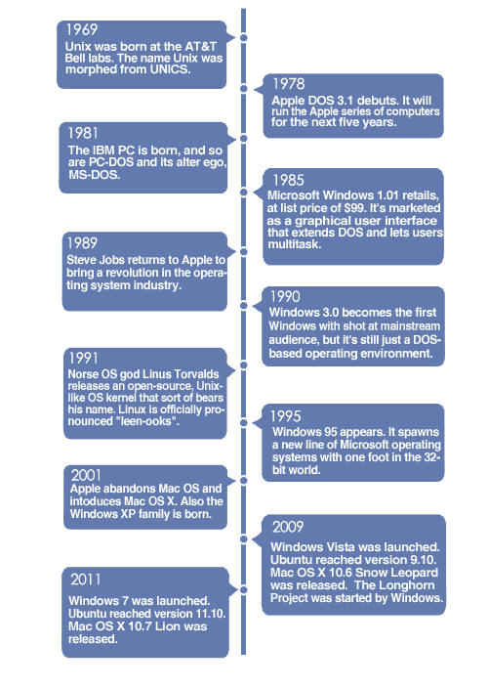
Timeline of Desktop Operating System
UNIX
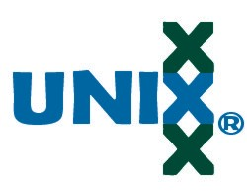
Unix (officially trademarked as UNIX) is a multitasking, multi-user computer operating system originally developed in 1969 by a group of AT&T employees at Bell Labs, including Ken Thompson, Dennis Ritchie, Brian Kernighan, Douglas McIlroy, Michael Lesk and Joe Ossanna. The UNIX operating system was first developed in assembly language, but by 1973 had been almost entirely recoded in C, greatly facilitating its further development and porting to other hardware. Today's Unix system evolution is split into various branches, developed over time by AT&T as well as various commercial vendors, universities (such as University of California, Berkeley's BSD), and non-profit organizations.
The UNIX Logo
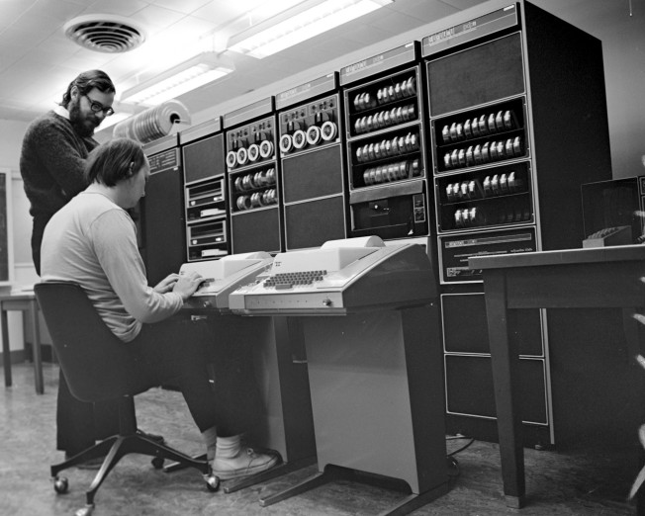
Dennis Ritchie, Ken Thompson working on UNIX in their lab.
The Open Group, an industry standards consortium, owns the UNIX trademark Unix-like operating systems such as MINIX, Linux, and BSD descendants (FreeBSD, NetBSD, OpenBSD, and DragonFly BSD) are commonly encountered. The term traditional UNIX may be used to describe an operating system that has the characteristics of either Version 7 Unix or UNIX System V. Unix operating systems are widely used in servers, workstations, and mobile devices. Originally, UNIX was meant to be a programmer's workbench more than to be used to run application software. The system grew larger as the operating system started spreading in the academic circle, as users added their own tools to the system and shared them with colleagues.
Both Unix and the C programming language were developed by AT&T and distributed to government and academic institutions, which led to both being ported to a wider variety of machine families than any other operating system. As a result, UNIX became synonymous with open systems. UNIX was designed to be portable, multi-tasking and multi-user in a time-sharing configuration. Unix systems are characterized by various concepts: the use of plain text for storing data; a hierarchical file system; treating devices and certain types of inter-process communication (IPC) as files; and the use of a large number of software tools, small programs that can be strung together through a command line interpreter using pipes, as opposed to using a single monolithic program that includes all of the same functionality. These concepts are collectively known as the UNIX philosophy
Under UNIX, the operating system consists of many utilities along with the master control program, the kernel. The kernel provides services to start and stop programs, handles the file system and other common "low level" tasks that most programs share and schedules access to avoid conflicts when programs try to access the same resource or device simultaneously. To mediate such access, the kernel has special rights, reflected in the division between user-space and kernel-space. The microkernel concept was introduced in an effort to reverse the trend towards larger kernels and return to a system in which most tasks were completed by smaller utilities.
The UNIX system is composed of several components that are normally packaged together. By including – in addition to the kernel of an operating system – the development environment, libraries, documents, and the portable, modifiable source-code for all of these components, UNIX was a self-contained software system. This was one of the key reasons it emerged as an important teaching and learning tool and has had such a broad influence.
THE STRUCTURE OF UNIX
The Unix Operating system is divided into 3 major parts and components
- The Kernel
- The Shell
- Utilities and Application Program
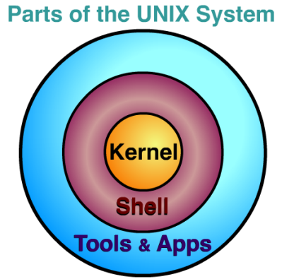
The Kernel: Kernel is the heart of the UNIX operating system. UNIX environment is maintained by tasks performed by it. It’s the interface between computers hardware and the Users.
The Shell: It is the interface between user and UNIX operating system. It allows user to interact and communicate with computer Utilities and Application Program: Utilities are the basic UNIX commands. Application programs such as database systems can be run alongside the UNIX commands. Utility or the application program can be run through the shell.

The UNIX system had significant impact on other systems. It won its success by:
- Direct interaction.
- Moving away from the total control of businesses like IBM and DEC.
- AT&T giving the software away for free.
- Running on cheap hardware.
- Being easy to adopt and move to different machines.

WINDOWS

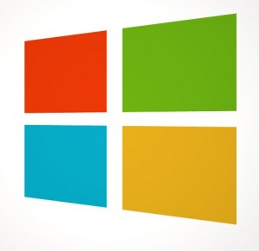
Microsoft Windows is a series of graphical interface operating systems developed, marketed, and sold by Microsoft.
The Windows Logo

Microsoft introduced an operating environment named Windows on November 20, 1985 as an add-on to MS-DOS in response to the growing interest in graphical user interfaces (GUIs). Microsoft Windows came to dominate the world's personal computer market with over 90% market share, overtaking Mac OS, which had been introduced in 1984.

The most recent client version of Windows is Windows 8; the most recent server version is Windows Server 2012; the most recent mobile version is Windows Phone 8.

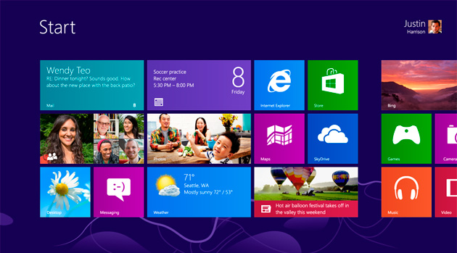

Windows 8 Metro UI
THE HISTORY OF WINDOWS

- 1975: Microsoft Boots Up

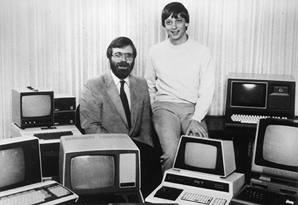
Microsoft co-founders: Paul Allen and Bill Gates

It’s the 1970s. At work, we rely on typewriters. If we need to copy a document, we likely use a mimeograph or carbon paper. Few have heard of microcomputers, but two young computer enthusiasts, Bill Gates and Paul Allen, see that personal computing is a path to the future.

In 1975, Gates and Allen form a partnership called Microsoft. Like most start-ups, Microsoft begins small, but has a huge vision—a computer on every desktop and in every home. During the next years, Microsoft begins to change the ways we work.

- 1982: Introducing Windows 1.0

Microsoft works on the first version of a new operating system. Interface Manager is the code name and is considered as the final name, but Windows prevails because it best describes the boxes or computing “windows” that are fundamental to the new system. Windows is announced in 1983, but it takes a while to develop. Skeptics call it “vaporware.”
On November 20, 1985, two years after the initial announcement, Microsoft ships Windows 1.0. Now, rather than typing MS DOS commands, you just move a mouse to point and click your way through screens, or “windows.” Bill Gates says, “It is unique software designed for the serious PC user…”There are drop-down menus, scroll bars, icons, and dialog boxes that make programs easier to learn and use. You're able to switch among several programs without having to quit and restart each one. Windows 1.0 ships with several programs, including MS DOS file management, Paint, Windows Writer, Notepad, Calculator, and a calendar, card file, and clock to help you manage day-to-day activities. There’s even a game—Reversi.

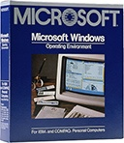
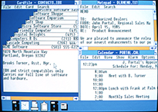
Fully Packaged Windows 1.0
Windows 1.0 Interface
- 1990: Windows 3.0 - Getting the graphics

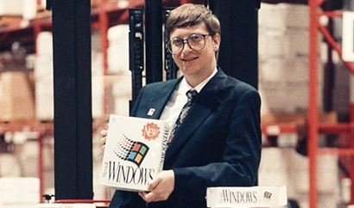
Bill Gates shows the newly-released Windows 3.0

On May 22, 1990, Microsoft announces Windows 3.0, followed shortly by Windows 3.1 in 1992. Taken together, they sell 10 million copies in their first 2 years, making this the most widely used Windows operating system yet. The scale of this success causes Microsoft to revise earlier plans. Virtual Memory improves visual graphics. In 1990 Windows starts to look like the versions to come. Windows now has significantly better performance, advanced graphics with 16 colors, and improved icons. A new wave of 386 PCs helps drive the popularity of Windows 3.0. With full support for the Intel 386 processor, programs run noticeably faster. Program Manager, File Manager and Print Manager arrive in Windows 3.0. Windows software is installed with floppy discs bought in large boxes with heavy instruction manuals.

The popularity of Windows 3.0 grows with the release of a new Windows software development kit (SDK), which helps software developers focus more on writing programs and less on writing device drivers. Windows is increasingly used at work and home and now includes games like Solitaire, Hearts, and Minesweeper. An advertisement: “Now you can use the incredible power of Windows 3.0 to goof off.” Windows for Workgroups 3.11 adds peer-to-peer workgroup and domain networking support and, for the first time, PCs become an integral part of the emerging client/server computing evolution.

- 1995: Windows 95 – the age of PC and the Internet

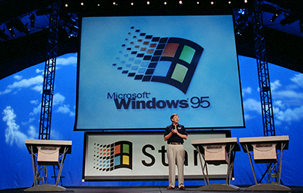
On August 24, 1995, Microsoft releases Windows 95, selling a record-setting 7 million copies in the first five weeks. It’s the most publicized launch Microsoft has ever taken on. Television commercials feature the Rolling Stones singing "Start Me Up" over images of the new Start button. The press release simply begins: “It’s here.”
This is the era of fax/modems, e mail, the new online world, and dazzling multimedia games and educational software. Windows 95 has built-in Internet support, dial-up networking, and new Plug and Play capabilities that make it easy to install hardware and software. The 32-bit operating system also offers enhanced multimedia capabilities, more powerful features for mobile computing, and integrated networking.
Launch day: Bill Gates introduces Windows
At the time of the Windows 95 release, the previous Windows and MS DOS operating systems are running on about 80 percent of the world’s PCs. Windows 95 is the upgrade to these operating systems. To run Windows 95, you need a PC with a 386DX or higher processor (486 recommended) and at least 4 MB of RAM (8 MB of RAM recommended). Upgrade versions are available for both floppy disk and CD-ROM formats. It’s available in 12 languages. Windows 95 features the first appearance of the Start menu, taskbar, minimize, maximize, and close buttons on each window.

- Catching the Internet wave

In the early 1990s, tech insiders are talking about the Internet—a network of networks that has the power to connect computers all over the world. In 1995, Bill Gates delivers a memo titled “The Internet Tidal Wave,” and declares the Internet as “the most important development since the advent of the PC.” In the summer of 1995, the first version of Internet Explorer is released. The browser joins those already vying for space on the World Wide Web.

- 2001: Windows XP - Stable, Usable and Fast
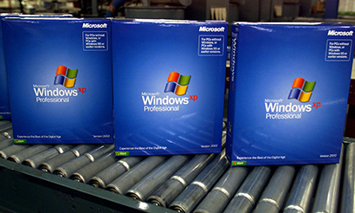
Packaged Copies of Windows XP Professional
On October 25, 2001, Windows XP is released with a redesigned look and feel that's centered on usability and a unified Help and Support services center. It’s available in 25 languages. From the mid-1970s until the release of Windows XP, about 1 billion PCs have been shipped worldwide.
For Microsoft, Windows XP will become one of its best-selling products in the coming years. It’s both fast and stable. Navigating the Start menu, taskbar, and Control Panel are more intuitive. Awareness of computer viruses and hackers increases, but fears are to a certain extent calmed by the online delivery of security updates. Consumers begin to understand warnings about suspicious attachments and viruses. There’s more emphasis on Help and Support. Windows XP Home Edition offers a clean, simplified visual design that makes frequently used features more accessible. Designed for home use, Windows XP offers such enhancements as the Network Setup Wizard, Windows Media Player, Windows Movie Maker, and enhanced digital photo capabilities.

Windows XP Professional brings the solid foundation of Windows 2000to the PC desktop, enhancing reliability, security, and performance. With a fresh visual design, Windows XP Professional includes features for business and advanced home computing, including remote desktop support, an encrypting file system, and system restore and advanced networking features. Key enhancements for mobile users include wireless 802.1x networking support, Windows Messenger, and Remote Assistance.

- 2006: Windows Vista - Smart on security
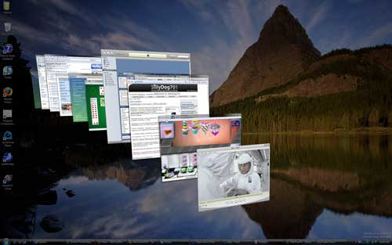
Windows Vista is released in 2006 with the strongest security system yet. User Account Control helps prevent potentially harmful software from making changes to your computer. In Windows Vista Ultimate, Bit Locker Drive Encryption provides better data protection for your computer, as laptop sales and security needs increase. Windows Vista also features enhancements to Windows Media Player as more and more people come to see their PCs as central locations for digital media. Here you can watch television, view and send photographs, and edit videos. Design plays a big role in Windows Vista, and features such as the taskbar and the borders around windows get a brand new look. Search gets new emphasis and helps people find files on their PCs faster. Windows Vista introduces new editions that each has a different mix of features. It's available in 35 languages. The redesigned Start button makes its first appearance in Windows Vista.
- 2009: Windows 7 and counting...

By the late 2000s, the wireless world has arrived. When Windows 7 is released in October 2009, laptops are outselling desktop PCs and it’s common to get online at public wireless hotspots like coffee shops. Wireless networks can be created at the office or at home.
Windows 7 includes many features, such as new ways to work with windows—Snap, Peek, and Shake. Windows Touch makes its debut, enabling you to use your fingers to browse the web, flip through photos, and open files and folders. You can stream music, videos, and photos from your PC to a stereo or TV.
By the fall of 2010, Windows 7 is selling seven copies a second—the fastest-selling operating system in history. Improvements to the Windows 7 taskbar include live thumbnail previews.

- What's next?

Many laptops no longer have a slot for DVDs and some have solid state drives rather than conventional hard disks. Most everything is streamed, saved on flash drives, or saved in the "Cloud"—an online space for sharing files and storage. Windows Live—free programs and services for photos, movies, instant messaging, e mail, and social networking—is seamlessly integrated with Windows so that you can keep in touch from your PC, phone, or the web, extending Windows to the Cloud.

Meanwhile, work is underway for the next version of Windows…..

MACINTOSH
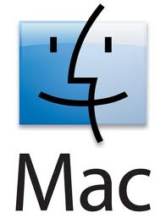
OS X is the newest of Apple Inc.'s Mac OS line of operating systems. Although, under its original name of Mac OS X, it was officially designated as simply "version 10" of the Mac OS, "version 9" had a completely different codebase, file system, design, and hardware support. Mac OS had been Apple's primary operating system since 1984, and the family was backward compatible, so OS X supported an emulated version 9 until version 10.5.

Unlike its predecessor, OS X is a Unix-like operating system built on technology that had been developed at NeXT through the second half of the 1980s and up until Apple purchased the company in early 1997. It was first released in 1999 as Mac OS X Server 1.0, with a desktop-oriented version (Mac OS X v10.0) following in March 2001. Since then, seven more distinct "client" and "server" editions of Mac OS X have been released, the most recent being Mac OS X v10.8, which was first made available on July 25, 2012. Releases of OS X are named after big cats; the current version of OS X is nicknamed "Mountain Lion".
The official Mac logo

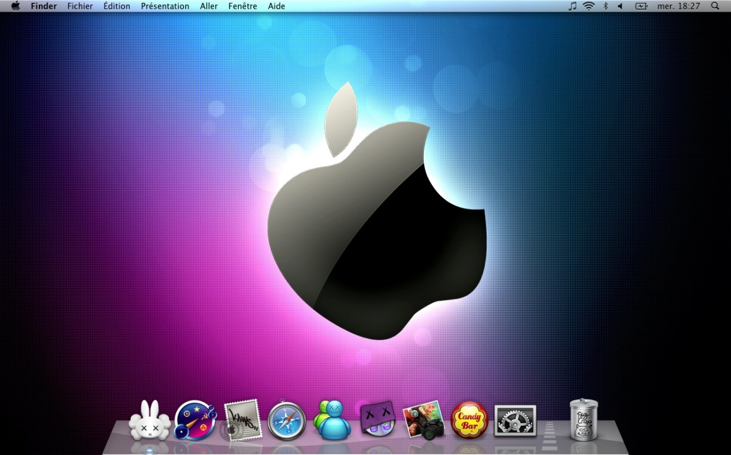
Home screen with Dock

HISTORY OF MAC OS
- Mac OS X Public Beta:
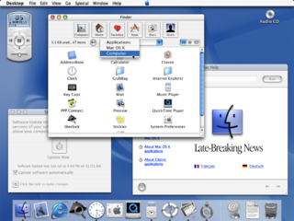
The Mac OS X Public Beta (internally codenamed "Kodiak") was an early beta version of Apple Computer's Mac OS X operating system Cheetah. It was released to the public on September 13, 2000 for US$29.95. It allowed software developers and early adopters to test a preview of the upcoming operating system and develop software for the forthcoming operating system before its final release. It had a build number of 1H39.] It moved the Apple menu from the left end of the menu bar to the center and rendered it nonfunctional.
First Release of MAC OS X

With the Mac OS X Public Beta came fundamental technical changes, most courtesy of an open source Darwin 1.2.1 core, including two features that Mac users had been anticipating for almost a decade: preemptive multitasking and protected memory. At the MacWorld Expo in June 2000, Apple CEO Steve Jobs demonstrated Bomb.app, a test application intended to crash.

- MAC OS X v 10.0
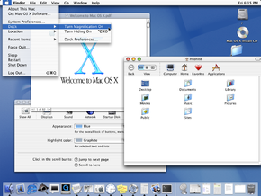
Mac OS X version 10.0, code named "Cheetah", is the first major release of Mac OS X, Apple’s desktop and server operating system. Mac OS X v10.0 was released on March 24, 2001 for a price of US$129. It was the successor of the Mac OS X Public Beta and the predecessor of Mac OS X v10.1. Mac OS X v10.0 was a radical departure from the previous “classic” Macintosh operating system and was Apple’s long awaited answer to the call for a next generation Macintosh operating system. It introduced a brand new code base completely separate from Mac OS 9's, as well as all previous Apple operating systems. Mac OS X introduced the new Darwin Unix-like core and a totally new system of memory management. It proved to be a rocky start to the Mac OS X line, plagued with missing features and performance issues, although it was praised for being a good start to an operating system still in its infancy, in terms of completeness and overall operating system stability. Unlike later releases of Mac OS X, the cat-themed code name was not used in marketing the new operating system.
MAC OS X 10.0 Cheetah

FEATURES:

- Dock — the Dock was a new way of organizing one's Mac OS X applications on a user interface, and a change from the classic method of Application launching in previous Mac OS systems.
- Mach 3.0 — the Unix-like microkernel was used for XNU operating systems, and was one of the largest changes from a technical standpoint in Mac OS X.
- Terminal — the Terminal was a feature that allowed access to Mac OS X's underpinnings, namely the UNIX core. Mac OS had previously had the distinction of being one of the few operating systems with no command line interface at all.
- Mail (e-mail client)
- Address Book
- New word processor replacing SimpleText called TextEdit.
- Full preemptive multitasking support, a long awaited feature on the Mac.
- PDF Support (create PDFs from any application)
- Aqua Interface
- Built on XNU, a Unix-like operating system and its Darwin development platform.
- OpenGL

CRITICISMS:

While the first Mac OS X release was an advanced operating system in terms of its technical underpinnings, and in relation to its brand new code-base, Mac OS X v10.0 was heavily criticized. There were three main reasons for criticism:
- Interface Responsiveness — The brand-new Aqua interface was sluggish at best. It was heavily criticized for its slow application launch speed and user interface response speed. The interface response times compared to earlier Apple operating systems showed that Mac OS X still had a long way to go in terms of interface performance.
- Stability — While 'theoretical' stability in Mac OS X was much better than stability in Mac OS 9, Mac OS X v10.0 was riddled with fatal bugs that caused kernel panics, especially in complex hardware setups.
- Missing Features and Hardware Compatibility Issues — Another reason for criticism were the missing features, especially missing DVD playback, as well as CD burning, both of which were available in Mac OS 9. Mac OS X v10.0.2 included the necessary software frameworks to allow iTunes 1.1.1 to provide audio CD burning support, but data CD burning had to wait until version 10.1. There were also several issues in respect to missing printer drivers and other hardware drivers.
The heavy criticism of Mac OS X version 10.0 ultimately resulted in Apple offering a free upgrade to Mac OS X v10.1.

- MAC OS X v 10.6 – Snow Leopard

Mac OS X Snow Leopard (version 10.6) is the seventh major release of Mac OS X, Apple's desktop and server operating system for Macintosh computers. Unlike previous versions of Mac OS X, the goals with Snow Leopard were improved performance, greater efficiency and the reduction of its overall memory footprint. Addition of new end-user features was not a primary goal. Much of the software in Mac OS X was extensively rewritten for this release in order to fully take advantage of modern Macintosh hardware. New programming frameworks, such as OpenGL, were created, allowing software developers to use graphics cards in their applications. This is also the first Mac OS release since System 7.1.1 that does not support Macs that use PowerPC processors, as Apple now intends to focus on its current line of Intel-based products. As support for
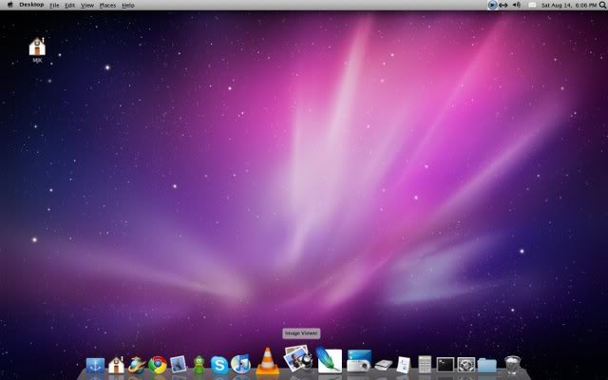
MAC OS X 10.6 Snow Leopard
Rosetta was dropped in Mac OS X Lion, Snow Leopard is the last version of Mac OS X that is able to run PowerPC-only applications.

Refinements to the user interface:

While the Finder was completely rewritten in Cocoa, it did not receive a major user interface overhaul. Instead, the interface has been modified in several areas to promote ease of use. These changes include:
- Exposé can now display windows for a single program by left clicking and holding its icon in the dock. Windows are arranged in a new grid pattern.
- Contextual menus which come out of Dock icons now have more options and have a new look, with a semi-transparent charcoal background and white text.
- An option has been added to the Finder preferences that allow the user to modify search behavior. The default setting can be selected to (1) search the entire computer, (2) search only the current folder from which the search was initiated, or (3) perform the search based on the previously used scope.
- The default gamma has been changed from 1.8 to 2.2 to better serve the color needs of digital content producers and consumers.
- Dock Stacks, when viewed as a grid, allow viewing of a subfolder as a new stack, rather than launching a Finder window, in a manner similar to "tunneling". When viewed as grids or lists, scroll-bars are provided to navigate folders with more items than the current screen resolution will accommodate, as the program does not scale the icons to show as many as possible the way it did in OS X 10.5.
- Windows can now be minimized directly onto their application's icon in the dock.
- Faster PDF and JPEG icon refreshes.
- When searching for a network, the AirPort menu-bar icon animates until it finds a network and shows network strength of available networks in the drop down menu.
- Snow Leopard shuts down and goes to sleep faster

Dropped features:

- AppleTalk is no longer supported.
- It is no longer possible to change an application's language using the Finder "Get Info" dialogue. While there are workarounds for some applications, others (such as Adobe After Effects).

- MAC OS X 10.7 – Mountain Lion
OS X Mountain Lion (version 10.8) is the ninth major release of OS X, Apple Inc.'s desktop and server operating system for Macintosh computers. OS X Mountain Lion was released on July 25, 2012. It gains features from iOS, such as Notes and Reminders as applications separate from Mail and Calendar, in addition to those iOS features introduced in Mac OS X Lion.

OS X Mountain Lion replaces iChat with Messages, which includes support for iMessage, allowing users to send unlimited messages to other Macs (running 10.8 or later), iPhones, iPads and iPod Touches (running iOS 5 or later). It also includes the latest version of the Safari web browser, Safari 6. Another feature from iOS 6 included in Mountain Lion is Notification Center, a sidebar pane that provides an overview of alerts from applications. It displays notifications until the user completes an associated action, rather than requiring instant resolution. OS X Mountain Lion received positive reviews, with critics praising Notification Center, Messages, and speed improvements over Mac OS X Lion, and criticizing Game Center for lack of games. Mountain Lion sold 3 million units in the first four days, making it Apple's most successful Mac release to date.

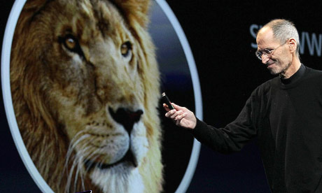
Steve Jobs during Mountain Lion release

NEW FEATURES:

- Notification Center
Notification Center is added in the operating system. It provides an overview of alerts from applications and displays notifications until the user completes an associated action, rather than requiring instant resolution. Users may choose what applications appear in Notification Center, and how they are handled. There are three types of notifications: banners, alerts, and badges. Banners are displayed for a short amount of time in the upper right corner of the Mac's screen, and then slide off to the right. The icon of the application is displayed on the left side of the banner, while the message from it will be displayed on the right side. Alerts are the same as banners, but will not disappear from the screen until the user takes action. Badges are red notification icons that are displayed on the application's icon. They tell the number of items available for the application.
- Notes
A note, a new notes application, is added. It is now separate from Mail in its own application; with support for desktop notes added (syncs along with its iOS counterpart).Created notes are synced through all the user's Apple devices through the iCloud service. Notes can be arranged in folders, and pinned to the user's desktop. When the application is closed, the pinned note still remains.
- Messages
Messages, an instant messaging software application, are added in Mountain Lion. It was announced on February 16, 2012, as part of the OS X Mountain Lion developer preview. Starting with this release, Messages replaces iChat as the default OS X instant-messaging client. A free beta version of Messages was available to download for Mac OS X Lion from the Apple website until late June 2012.The final version of Messages was included with the release version of OS X Mountain Lion.

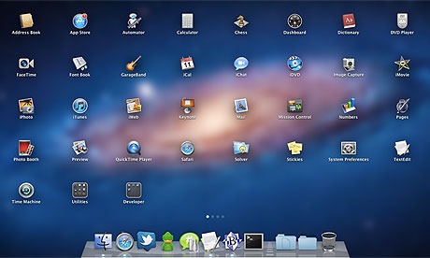
Mountain Lion installed apps
- Game Center
The Game Center application from iOS was added in OS X. It is an online multiplayer social gaming network, and allows users to invite friends to play a game, start a multiplayer game through matchmaking, track their achievements, and compare their high scores on a leader board. Points are awarded to players as a part of Game Center's achievement tracking system. Players can earn points by meeting specific in-game challenges.
- Application updates
OS X Mountain Lion added many updates for applications on the operating system. The Chess app now supports Game Center. Dashboard widgets can be managed in a UI similar to Launchpad. Mail adds new VIP feature to save frequent contacts. The Preview app gets an improved user interface. It is now able to fill out forms in PDF documents that don't contain actual PDF form fields. Reminders is a new to-do list application, now separate from Calendar in its own application that syncs along with its iOS counterpart. Safari 6 gets a new release and features a new omnibar; a combination of the address bar and the search field. The omnibar also has a "Reader" button, showing the user just the text of the article without advertisements and distraction. When the user is on a website with no article, the button is disabled. Safari 6 is also available as a download for Mac OS X Lion. Time Machine is now able to do rotating backups on more than one storage medium.

Dropped and changed features:

One of the largest changes in Mountain Lion is that MobileMe has been replaced entirely by iCloud, specifically in System Preferences options. RSS support in Mail and Safari has been removed; a message is shown to suggest to users that they search the Mac App Store for an RSS app. The Software Update service has been unified into the Mac App Store. The list of updates installed in the past has been removed. The "Web Sharing" option removed from System Preferences.Apache is still included with the operating system and can be enabled using third-party software.

When X11.app is opened, users are directed to the open source XQuartz project instead. Xgrid support has been removed (including in OS X Server edition).The Display Preference Menu has been replaced by the AirPlay icon, and it is no longer possible to quickly switch resolutions without first opening up preferences. The option in Menu Bar to display battery life using "Time" is no longer offered. Instead, the only option is to display battery "Percentage". However, battery time can still be viewed in the dropdown by clicking on the battery icon. Older models of Canon printers may not be supported.

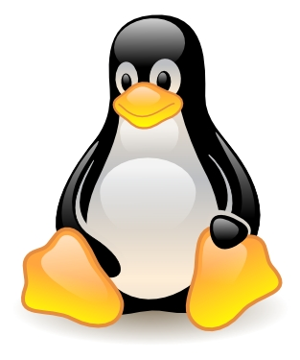
LINUX
Linux is a Unix-like computer operating system assembled under the model of free and open source software development and distribution. The defining component of Linux is the Linux kernel, an operating system kernel first released 5 October 1991 by Linus Torvalds.
Linux was originally developed as a free operating system for Intel x86-based personal computers. It has since been ported to more computer hardware platforms than any other operating system. It is a leading operating system on servers and other big iron systems such as mainframe computers and supercomputers: more than 90% of today's 500 fastest supercomputers run some variant of Linux, including the 10 fastest. Linux also runs on embedded systems (devices where the operating system is typically built into the firmware and highly tailored to the system) such as mobile phones, tablet computers, network routers, televisions and video game consoles; the Android system in wide use on mobile devices is built on the Linux kernel.
Tux - The Linux Mascot
Today, Linux systems are used in every domain, from embedded systems to supercomputers, and have secured a place in server installations often using the popular LAMP application stack. Use of Linux distributions in home and enterprise desktops has been growing. They have also gained popularity with various local and national governments. The Indian state of Kerala has gone to the extent of mandating that all state high schools run Linux on their computers. The federal government of Brazil is well known for its support for Linux. News of the Russian military creating its own Linux distribution has also surfaced, and has come to fruition as the G.H.ost Project.

A Linux-based system derives much of its basic design from principles established in UNIX during the 1970s and 1980s. Such a system uses amonolithic kernel, the Linux kernel, which handles process control, networking, and peripheral and file system access. Device drivers are either integrated directly with the kernel or added as modules loaded while the system is running.
Separate projects that interface with the kernel provide much of the system's higher-level functionality. The GNU user land is an important part of most Linux-based systems, providing the most common implementation of the C library, a popular shell, and many of the common UNIX tools which carry out many basic operating system tasks. The graphical user interface (or GUI) used by most Linux systems is built on top of an implementation of the X Window System.
Some components of an installed Linux system are:
- A bootloader - for example GRUB or LILO. This is a program which is executed by the computer when it is first turned on, and loads the Linux kernel into memory.
- An init program. This is a process launched by the Linux kernel, and is at the root of the process tree: in other terms, all processes are launched through init. It starts processes such as system services and login prompts (whether graphical or in terminal mode)
- Software libraries which contain code which can be used by running processes. On Linux systems using ELF-format executable files, the dynamic linker which manages use of libraries is "ld-linux.so". The most commonly used software library on Linux systems is the GNU C Library.
- User interface programs such as command shells or windowing environments
Users operate a Linux-based system through a command line interface (CLI), a graphical user interface (GUI), or through controls attached to the associated hardware, which is common for embedded systems. For desktop systems, the default mode is usually a graphical user interface, by which the CLI is available through terminal emulator windows or on a separate virtual console. Most low-level Linux components, including the GNU userland, use the CLI exclusively. The CLI is particularly suited for automation of repetitive or delayed tasks, and provides very simple inter-process communication. A Linux system typically implements a CLI by a shell, which is also the traditional way of interacting with a UNIX system. A Linux distribution specialized for servers may use the CLI as its only interface.
The primary difference between Linux and many other popular contemporary operating systems is that the Linux kernel and other components are free and open source software. Linux is not the only such operating system, although it is by far the most widely used. Some free and open source software licenses are based on the principle of copyleft, a kind of reciprocity: any work derived from a copyleft piece of software must also be copyleft itself. The most common free software license, the GNU GPL, is a form of copyleft, and is used for the Linux kernel and many of the components from the GNU project.Most Linux distributions support dozens of programming languages. Linux is a widely ported operating system kernel. The Linux kernel runs on a highly diverse range of computer architectures: in the hand-held ARM-based iPAQ and the mainframe IBM System z9,System z10; in devices ranging from mobile phones to supercomputers.
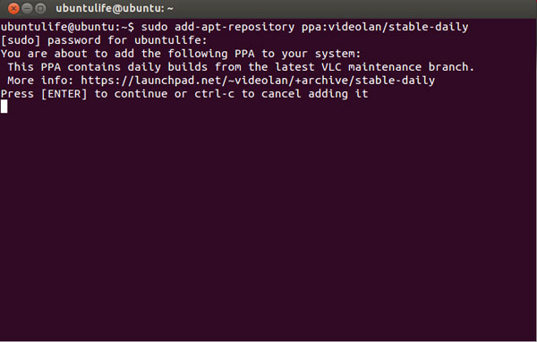
The Linux Terminal (CLI)

The popularity of Linux on standard desktop computers and laptops has been increasing over the years. Currently most distributions include a graphical user environment, with the two most popular environments being GNOME (which can utilize additional shells such as the default GNOME Shell and Ubuntu Unity), and the KDE Plasma Desktop.
Due to its low cost and ease of customization, Linux is often used in embedded systems. Android—based on a modified version of the Linux kernel—has become a major competitor of Nokia's older Symbian OS, found in many smartphones. During the third quarter of 2010, 25.5% of smartphones sold worldwide used Android (with all Linux variants forming 27.6% of the total during that time). Cell phones and PDAs running Linux on open-source platforms became more common from 2007; examples include the Nokia N810, Openmoko's Neo1973, and the Motorola ROKR E8.
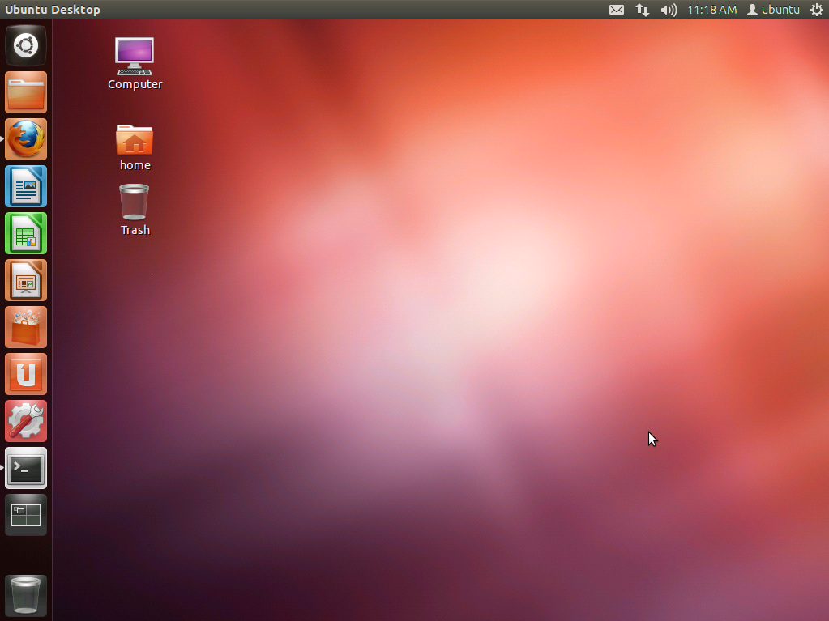
The Ubuntu Linux 12.04
STATISTICS

THE FUTURE OF OPERATING SYSTEMS

Although it might look a bit distant, the possibility of every computer being booted over the cloud does not seem improbable by any means. A few months ago when the Chrome CR-48 notebook was given away by Google for testing, quite a few loved the way everything was saved on the cloud and Android devices could be used to fetch the same content.With speedy developments in communication technologies and the availability of these services spreading rapidly, it might soon be possible for all of us to boot our machines over a cloud hosted by our Internet service providers (ISPs).

- Cloud Boots
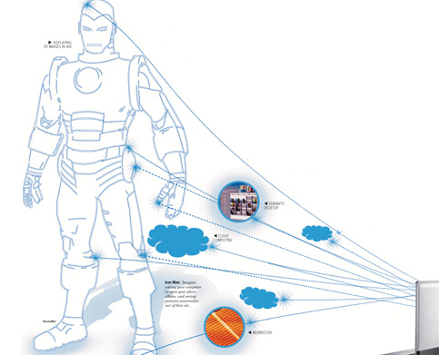
Imagine asking your computer to open your photo album, and seeing pictures materialize out of thin air. With Apple featuring operating system (OS) installation over Wi-Fi on its Macbook Air and Mac Mini product lines, it’s not difficult to imagine a scenario where your netbook will be able to boot into its (at least, a secondary) OS using your ISP’s data connection.
A patent filed by Apple titled “Method and Apparatus for Administering the Operating System of a Net-booted Environment” talks about a network computer system comprising a server and various clients. Different clients can receive their “operating systems” from the server with the help of one of the clients.
Is this the beginning of an era? Maybe. Apple has said the OS “may also be downloaded as a computer program product, wherein the program may be transferred from a remote computer (e.g., a server) to a requesting computer (e.g., a client) by way of data signals embodied in a carrier wave or other propagation medium via a communication link (e.g., a modem or network connection)”.
With this patent, it seems the war for controlling the user’s PC is going to intensify, and the day is not far when you might receive your OS over a network connection.

- Memristor

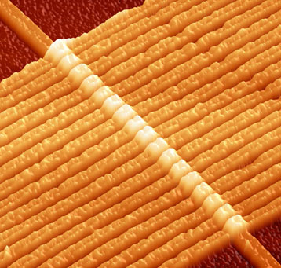
Hewlett-Packard (HP) has been successful at creating the first prototype of a working “memristor”, which allows memory chips to retain information. A memristor changes its resistance depending on how much current passes through it. Since it can remember how much current passed through it, information storage is possible. The very high-density storage capacities of chips made with a memristor indicate that RAM may soon become obsolete, for memristor chips allow greater data density, and access speeds similar to DRAM, or dynamic RAM. This will ring in some pleasant changes in the OS, with huge storage capacities that can act as both RAM and HDDs. Since you could have both the HDD and RAM in one unit, booting time will be unimaginably short—we’re talking 0.35 seconds. Hibernation and sleep would be almost instant and you may never need to shut down your computer.HP has been successful at making storage chips which can have some (real) high-storage capacities at 100 gigabits per cm sq. and about 1 petabit per cm cu. This technology will bridge the gap between volatile (memory that is lost when the computer is shut down) and non-volatile storage (memory that is permanently stored in the computer).
Memristors: 17 in a row

- Two in One

The world today means “RAM” when it talks “memory” and means “disks” when it talks “storage”. Well, that might change quite a byte (that’s eight times a “bit”) in the future.
Let’s consider a few facts about graphics processing units (GPUs). Graphics cards have as many as 1,024 processors within them. On certain operations, they can beat CPUs by more than a scale of 20. Many algorithms (for example, encryption algorithms) can run much faster on graphics processors than a CPU. In 10 or 15 years, we might have our own weather forecaster, health assistant and complete social planner on our machines, powered by the OS itself. By which we mean the “graphics card”, thanks to parallel kernels.

- Displaying 3D in Air

This concept in the way OSes of the future will look could really strain your imagination (though it might be simpler if you’ve seen Iron Man). We’re talking about drawing objects in the air. Windows 7 has transparency and flipping, Compiz too had a bit of 3D behaviour built in. Now imagine you’re sitting at your chair asking your computer to open your photo album, and you are shown pictures right in the air, no display attached!
In this technology, laser-produced plasma technology is used to produce flashpoints in the air. Optimizing the laser beams, the brightness, contrast and production distance of such flashpoints can be adjusted. This technology is capable of producing 3D images in a space where there is nothing but “air”. One of the first successful project in its field is on at the National Institute of Advanced Industrial Science and Technology (AIST), Japan.

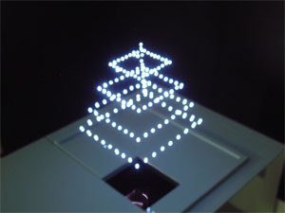
3D-objects displayed using a 3D-image spatial drawing device

- Semantic Desktop

Of late OSes have become significantly better at searching the Net too. But in the future we’re likely to have a semantic desktop, which will be able to understand the meaning and importance of files stored on the system. It will understand the needs and behavior of its user, and the system will adapt accordingly. So if you open your calendar to find your best friend’s birthday is today and click an icon with his image, you will come to know when you last interacted with him via email or a social network. You can send him a picture slide-show video with a customized music background. You will click the “create slide show” button and all the images of both of you that are tagged across all your social networking accounts will be fetched and displayed. You would then be presented with a media editing program for the slide show.
To do all that, the OSes will be able to use the files’ data as metadata for search and interlink the files with various other objects on the system. They will be able to analyze the behavior of the user and predict his needs based on it. All this would be tightly integrated into the social and semantic Web.

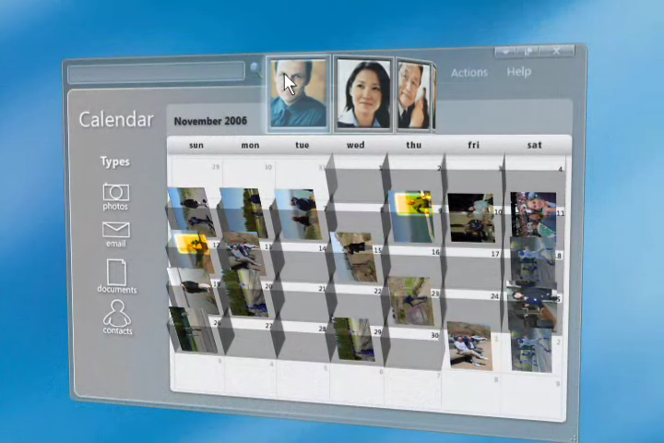
Mockup of a Calendar in a Semantic OS
CONCLUSION

Thus we can conclude that all operating systems have risen from the first major operating system called UNIX going through loads of changes in their long lifespan. We have seen how each operating system developed into the form they are now, and the people behind the tremendous success of those. We saw how the usage of operating systems varies in the home v/s the commercial environment. But the technology yet to come is even more interesting and mindboggling. The research and development going on in this field is tremendous. Some operating systems will die, some new will emerge and some may even change the fundamental working of the current ones. Whatever be the case operating systems will always be an integral part of the computer and its working.
BIBLIOGRAPHY

- http://www.iterating.com/productclasses/Operating-Systems
- http://duartes.org/gustavo/blog/post/how-computers-boot-up
- http://www.linuxdevices.com/articles/AT4627965573.html
- http://www.wisegeek.com/what-is-an-operating-system.htm
- http://safari.oreilly.com/0789734249/part01
- http://www.unix.org/what_is_unix.html
- http://computer.howstuffworks.com/operating-system.htm
- http://www.apple.com/in/osx/
- http://www.ubuntu.com/project/about-ubuntu
- http://en.wikipedia.org/wiki/Operating_system
- http://windows.microsoft.com/en-GB/windows/explore/get-to-know
- http://www.livemint.com/Leisure/Operating-systems-of-the-future.html
- http://www.aist.go.jp/aist_e/latest_research/2006/20060210.html
- http://news.cnet.com/8301-10784_3-9932054-7.html

