- Game-The Definition(Overview)
Considered by some as a curiosity in the mid-1970s, the computer and video game industries have grown from focused markets to mainstream. They took in about US$9.5 billion in the US in 2007, 11.7 billion in 2008, and 25.1 billion in 2010 (ESA annual report).
Modern personal computers owe many advancements and innovations to the game industry: sound cards, graphics cards and 3D graphic accelerators, CD ROM and DVD-ROM drives, are a few of the more notable improvements.
Sound cards were developed for addition of digital-quality sound to games and only later improved for music and audiophiles. Early on, graphics cards were developed for more colors. Later, graphics cards were developed for graphical user interfaces (GUIs) and games. GUIs drove the need for high resolution, games drove 3D acceleration. They also are one of the only pieces of hardware to allow multiple hookups (such as with SLI or CrossFire graphics cards). CD- and DVD-ROMs were developed for mass distribution of media in general, however the ability to store more information on cheap easily distributable media was instrumental in driving their ever higher speeds.
Modern games are among the most demanding of applications on PC resources. Many of the high-powered personal computers are purchased by gamers who want the fastest equipment to power the latest cutting-edge games. Thus, the inertia of CPU development is due in part to this industry whose games demand faster processors than business or personal applications.



The game industry value chain is made up of six connected and distinctive layers:
- Capital and publishing layer: involved in paying for development of new titles and seeking returns through licensing of the titles.
- Product and talent layer: includes developers, designers and artists, who may be working under individual contracts or as part of in-house development teams.
- Production and tools layer: generates content production tools, game development middleware, customizable game engines, and production management tools.
- Distribution layer: or the "publishing" industry, involved in generating and marketing catalogs of games for retail and online distribution.
- Hardware (or Virtual Machine or Software Platform) layer: or the providers of the underlying platform, which may be console-based, accessed through online media, or accessed through mobile devices such as smartphones. This layer now includes non-hardware platforms such as virtual machines (e.g. Java or Flash), or software platforms such as browsers or even further Facebook, etc.
- End-users layer: or the users/players of the games.
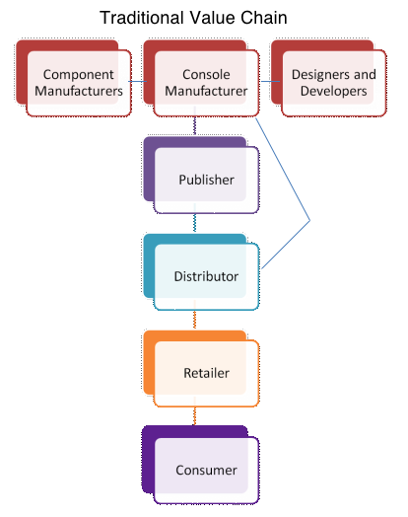

2. History :

The video game system industry had their major debut in 1967 when the first console, called The Brown Box, was introduced by Ralph Bare. Since then there have been dramatic improvements and innovations throughout this industry’s history and it will continue to grow in

the future. The following timeline lays out the major breakthroughs that have occurred in this business and shows how video games have evolved over the last 43 years.

2.1 Video Game System Timeline
1967
1972

1975
1977

1980
1985
1989

1991
1995

1996
1999

2000
2001
2002

2004
2005

2006

Nintendo 64 is released marking the last console to use cartridges.
Mattel releases the Intellevision to challenge Atari.
Atari sells the first home version of Pong.
The Super Nintendo is released.
The Nintendo Entertainment System is released in the U.S.
Atari releases the 2600 SPACE VCS. This is the first console that can play multiple games.
Magnavox begins production of the first commercial video game console, The Odyssey.
The first video game console was called the brown box and was designed by German born Ralph Bare

Nintendo introduces the first Game Boy. Sega also introduces the Sega Genesis.
Sony releases the PlayStation 1.

The Sega Dreamcast is introduced by Sega.
Sony releases the PlayStation 2.
Microsoft enters the video game system industry with their introduction of the XBOX.
Nintendo releases the new Game Boy Advance.
The Nintendo DS is released.
Sony releases the PlayStation Portable (PSP) to challenge Nintendo’s dominance in the handheld gaming market.
Mass release of the Nintendo Wii, Sony’s PlayStation 3, and Microsoft’s XBOX 360.

3. Ethical Aspects
1. Logical Processing
2. Creative Problem Solving
3. Responsibility
4. Math
5. Cognitive Thinking Skills
6. Leadership Skills
7. Scientific Method
8. Communication
9. Participatory Creativity (fanfic, fanart, modding, design)
10. Value of Co-operative efforts
11. Management Skills
12. Social Relationship Skills
13. Planning and Resource Management
14. Media Literacy
15. Professional Networking

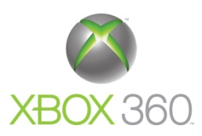
4. Gaming Platforms
4.1 Microsoft’s XBOX 360 :
Specifications :
Хboх 360 System
Custom IBM PowerPC-based CPU | - 3 symmetrical cores running at 3.2 GHz each  - 2 hardware threads per core; 6 hardware threads total  - 1 VMX-128 vector unit per core; 3 total  - 128 VMX-128 registers per hardware thread  - 1 MB L2 cache
CPU Game Math Performance | - 9 billion dot product operations per second
Custom ATI Graphics Processor | - 500 MHz  - 10 MB embedded DRAM  - 48-way parallel floating-point dynamically-scheduled shader pipelines  - Unified shader architecture
Polygon Performance | - 500 million triangles per second
Pixel Fill Rate | - 16 gigasamples per second fillrate using 4X MSAA
Shader Performance | - 48 billion shader operations per second
Memory | - 512 MB GDDR3 RAM  - 700 MHz DDR  - Unified memory architecture
Memory Bandwidth | - 22.4 GB/s memory interface bus bandwidth  - 256 GB/s memory bandwidth to EDRAM  - 21.6 GB/s front-side bus
Overall System Floating-Point Performance | - 1 TFLOP
Storage | - Detachable and upgradeable 20 GB hard drive  - 12X dual-layer DVD-ROM  - Memory unit support starting at 64 MB
I/O | - Support for up to 4 wireless game controllers  - 3 USB 2.0 ports  - 2 memory unit slots
Optimized for Online | - Instant, out-of-the-box access to Xbox Live features, including Xbox Live Marketplace for downloadable content, Gamer Profile for digital identity and voice chat to talk to friends while playing games, watching movies or listening to music  - Built in Ethernet Port  - Wi-Fi Ready: 802.11 A, B and G  - Video Camera Ready
Digital Media Support | - Support for DVD-Video, DVD-ROM, DVD-R/RW, DVD+R/RW, CD-DA, CD-ROM, CD-R, CD-RW, WMA CD, MP3 CD, JPEG Photo CD  - Stream media from portable music devices, digital cameras, Windows XP PCs  - Rip music to Xbox 360 hard drive  - Custom playlists in every game  - Windows Media Center Extender built in  - Interactive, full screen 3D visualizers
HD Game Support | - All games supported at 16:9, 720p and 1080i, anti-aliasing  - Standard definition and high definition video output supported
Audio | - Multichannel surround sound output  - Supports 48 KHz 16-bit audio  - 320 independent decompression channels  - 32-bit audio processing  - Over 256 audio channels
System Orientation | - Stands vertically or horizontally
Customizable Face Plates | - Interchangeable to personalize the console
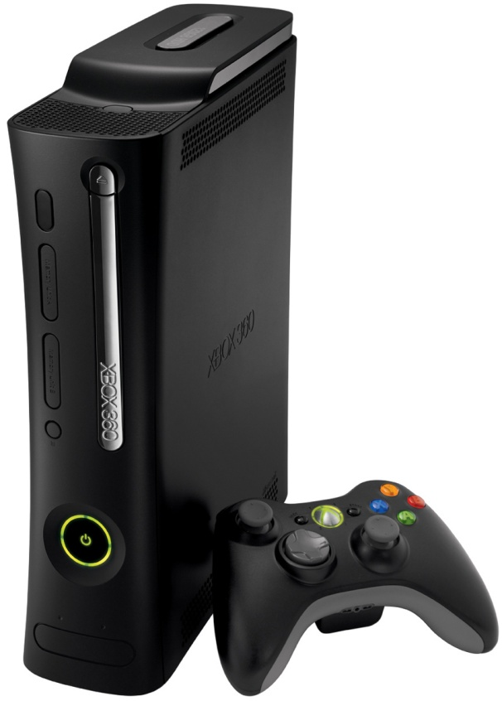

4.2 Sony Play Station : 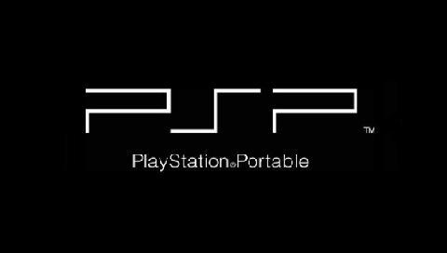

PSP Product Specifications :
- Product Name: PlayStation Portable (PSP)
- Color: Black
- Dimensions: Approx. 170 mm (L) x 74 mm (W) x 23 mm (D)
- Weight: Approx. 260 g (including battery)
- CPU: PSP CPU (System clock frequency 1~333MHz)
- Main Memory: 32MB
- Embedded DRAM: 4MB
- Display: 4.3 inch, 16:9 widescreen TFT LCD, 480 x 272 pixel (16.77 million colors), Max. 200 cd/m2 (with brightness control)
- Speakers: Built-in stereo speakers
- Main Input/Output: IEEE 802.11b (Wi-Fi), USB 2.0 (Target), Memory Stick™ PRO Duo, IrDA, IR Remote (SIRCS)
- Disc Drive: UMD Drive (Playback only)
- Profile: PSP Game, UMD Audio, UMD Video
- Main Connectors: DC OUT 5V, Terminals for charging built-in battery, Headphone/Microphone/Control connector
- Keys/Switches: Directional buttons (Up/Down/Right/Left)Analog pad, Enter keys (Triangle, Circle, Cross, Square), Left, Right keys START, SELECT, HOME, POWER On/Hold/Off switch, Brightness control, Sound Mode, Volume +/-, Wireless LAN On/Off switch, UMD Eject
- Power: Built-in lithium-ion battery, AC adaptor
- Access Control: Region Code, Parental Control
- Accessories: Stand, Headphone with remote commander, Headphone with remote commander and microphone, External battery pack, Case, Strap
- E3 Prototype Exhibition: USB Camera for PSP, USB GPS for PSP, USB Keyboard for PSP

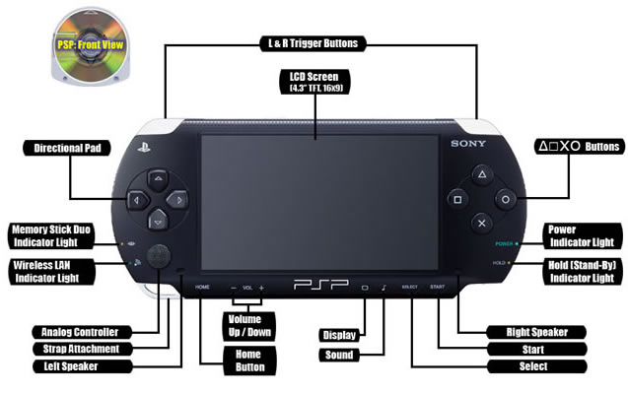


4.3 Nintendo Wii :
Specifications:
CPU
PowerPC CPU (code-named "Broadway") jointly developed with and manufactured by IBM.

Graphics Processing Unit

Developed with ATI/AMD.

The Specs
The Wii console has 512 megabytes of internal flash memory, two USB 2.0 ports and built-in wired and wireless sbroadband Internet capability. A bay for an SD memory card (or High Capacity SD card – both sold separately) lets players expand the internal flash memory and launch downloaded games directly from the cards. Design is optimized with state-of-the-art processing technologies that minimize power consumption, keep the console quiet and compact, and enable the "sleepless" WiiConnect24 mode.
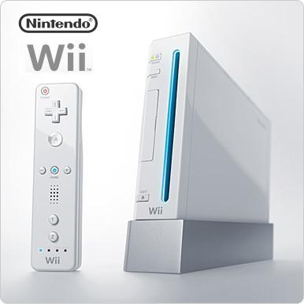

5. Types of Gaming :
5.1 Platform Gaming: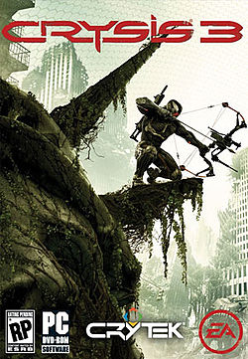
A PC game, also known as a computer game, is a video game played on a personal computer, rather than on a video game console or arcade machine. PC games have evolved from the simple graphics and gameplay of early titles like Spacewar!, to a wide range of more visually advanced titles.
PC games are created by one or more game developers, often in conjunction with other specialists (such as game artists) and either published independently or through a third party publisher. They may then be distributed on physical media such as DVDs and CDs, as Internet-downloadable, possibly freely redistributable, software, or through online delivery services such as Direct2Drive and Steam. PC games often require specialized hardware in the user's computer in order to play, such as a specific generation of graphics processing unit or an Internet connection for online play, although these system requirements vary from game to game.

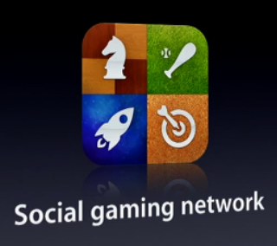
5.2 Social Gaming:
Summing up the formal characteristic of play, we might call it a free activity standing quite consciously outside 'ordinary' life as being 'not serious' but at the same time absorbing the player intensely and utterly. It is an activity connected with no material interest, and no profit can be gained by it. It proceeds within its own proper boundaries of time and space according to fixed rules and in an orderly manner. It promotes the formation of social groupings that tend to surround themselves with secrecy and to stress the difference from the common world by disguise or other means.
Note the mention of social groupings in Huizinga’s definition of play, indicating the importance of social factors in an environment of play. Social network games are games in essence, riding on some form of social network as the gaming platform. They follow the same game features as outlined by JesperJuul.
- Rules: Games are based on rules.
- Variable, quantifiable outcomes: Games have variable, quantifiable outcomes.
- Values assigned to possible outcomes: Games have different values assigned to different potential outcomes.
- Player effort: The outcomes of games are influenced by the players’ effort.
- Player attached to outcome: Each player of a game is attached to the outcomes.
- Negotiable consequences: Games can be played according to the same rules with or without real-life consequences.

Technology & platforms :
A social network video game can be created with any number of traditional video game technologies, however the majority are implemented in Adobe Flash, PHP or JavaScript. Some games may use a combination of these technologies.
A social network game is often played via a web browser, though they are distinct from browser based games in the way they leverage the player's social graph and individual user data that is hosted on the social network. With the invention of smartphone devices, social games have now also seen widespread adoption on mobile platforms such as iOS and Android devices. This is enabled through mobile social networks such as OpenFeint and through Oauth implementations by social networking sites like Facebookwhich allow applications on mobile devices to access a limited amount of protected user data on those sites. Through an in-app connection to these networks, users can be provided with an experience very similar to that of a web based social game. It's been predicted that social gaming will bring over 6 billion dollars in revenue, by 2013.

5.3 Mobile Gaming :
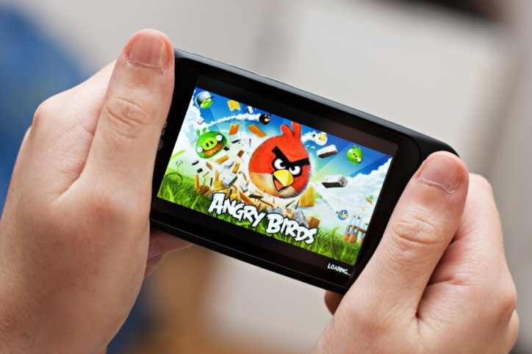
A mobile game is a video game played on a mobile phone, smartphone, PDA, tablet computer, portable media player or calculator. This does not include games played on dedicated handheld video game systems such as Nintendo 3DS or PlayStation Vita.
The first game on a mobile phone was a Tetris game on the Hagenuk MT-2000 device from 1994.
Three years later Nokia launched the very successful Snake on selected models in 1997. Snake and its variants has since become one of the most-played video games and is found on more than 350 million devices worldwide.
Mobile games are played using the technology present on the device itself. For networked games, there are various technologies in common use. Examples include text message (SMS), multimedia message (MMS) or GPS location identification. The first two-player game for mobile phones was a variant of the Snake game for the Nokia 6110, using the infrared port.
However, there are non networked applications, that simply use the device platform to run the game software. The games may be installed over the air,side loaded onto the handset with a cable, or may be embedded in the handheld devices by the OEM or by the mobile operator.
Mobile games are usually downloaded via the mobile operator's network, but in some cases are also loaded in the mobile handsets when purchased, via infrared connection, Bluetooth, or memory card.

5.4 Kinect (Motion Sensing):
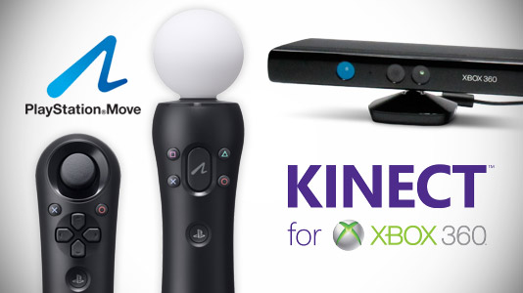
Kinect is a motion sensinginput device by Microsoft for the Xbox 360video game console and WindowsPCs. Based around a webcam-style add-on peripheral for the Xbox 360 console, it enables users to control and interact with the Xbox 360 without the need to touch a game controller, through a natural user interface using gestures and spoken commands. The project is aimed at broadening the Xbox 360's audience beyond its typical gamer base. Kinect competes with the Wii Remote Plus and PlayStation Move with PlayStation Eyemotion controllers for the Wii and PlayStation 3 home consoles, respectively. A version for Windows was released on February 1, 2012.
Kinect was launched in North America on November 4, 2010, in Europe on November 10, 2010, in Australia, New Zealand and Singapore on November 18, 2010, and in Japan on November 20, 2010. Purchase options for the sensor peripheral include a bundle with the game Kinect Adventures and console bundles with either a 4 GB or 250 GB Xbox 360 console and Kinect Adventures.
After selling a total of 8 million units in its first 60 days, the Kinect holds the Guinness World Record of being the "fastest selling consumer electronics device". 18 million units of the Kinect sensor had been shipped as of January 2012.
Microsoft released Kinect software development kit for Windows 7 on June 16, 2011. This SDK will allow developers to write Kinecting apps in C++/CLI, C#, or Visual Basic .NET.

6. Game Genres :

- Adventure: Adventure games involve exploration of, and interaction with, the environment as a main facet of gameplay. Story and puzzle solving are also highlighted and interaction is usually driven by point and click. Fighting plays a minor role. Adventure games include Zork and Myst.

- Classic Arcade: Classic arcade games refer to games that originally existed on freestanding coin-operated machines. Classic arcade games include Pong and Space Invaders
- Fighting: Fighting games involves rendering opponents unconscious or dead by using a number of different moves. Gameplay tactics are limited to selecting the most appropriate move in a situation. Fighting games include Tekken 3 and Street Fighter.

- Puzzle: Puzzle games are short but addictive graphical games that usually require the player to solve a puzzle such as a maze, logical problem or positioning different pieces together. Puzzle games include Tetris and Bust A Move (Puzzle Bobble)
- Racing Games: Racing games involve the player competing in races. Racing games include Daytona and the Mario Kart series.
- RPG: 'Role Playing Games' are games in which the player's character has skills and abilities represented by statistics. Gameplay involves the characters exploring and completing quests that build up their statistics and possessions. Can be single or multi-player. RPGs include Everquest and Ultima

- Shooters: Shoot em' Up or Shooter games involve shooting or destroying multiple objects and opponents. Shoot 'em up games include Doom and Asteroids.

- Strategy Games: Strategy games require the player to take on a leadership role and oversee every detail of the provided scenario(s). Gameplay focuses on strategies and careful planning and resource management in order to win. Strategy games include Age of Mythology.

- Simulations: Simulation games attempt to realistically mimic conditions of a particular environment or activity. Sim games include SimCity and Flight emulators.
- Sports Games: Sports Games emulate traditional physical sports such as basketball and golf.

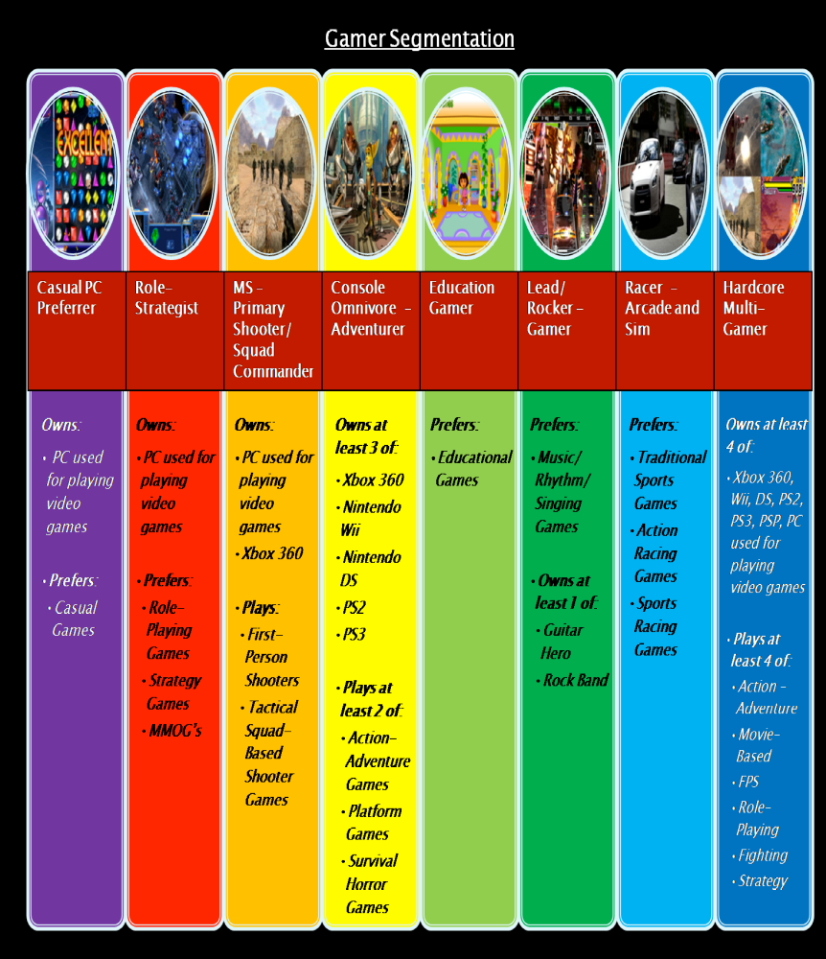

7. Industrial Aspects :
Industry Analysis for Video Game System Industry :
Industry Classification. The North American Industry Classification System (NAICS) code for video game systems is 339932 titled Game, Toy, and Children’s Vehicle Manufacturing. Yahoo Finance categorizes the sector for Sony as consumer goods and the industry as electronic equipment. For Microsoft, they are in the technology sector where the industry is application software. Since Nintendo is not publicly traded in the United States, they are not classified under Yahoo finance, however are classified under other products in the Tokyo Stock Exchange.

The video game console is the product that defines this industry. The machines considered throughout this report are: Microsoft’s XBOX 360, Sony’s PlayStations 2 and 3 as well as their PlayStation Portable (PSP), and Nintendo’s Wii and DS. These are not the only consoles still available on the current market, however, are the latest produced, thus are the basis for this entire report.

Geographic Scope. Microsoft is home-based in Redmond, WA; Sony is based in Tokyo, Japan; and Nintendo is based in Kyoto, Japan. The following pie charts represent the geographic markets the video game systems primarily serve.

Geographic Markets for Video Game System Industry as a Whole

A more specific way to breakdown the geographic scope of our industry is to break the preceding pie chart into individual competitors. The following series of pie charts represent the geographic scopes of Microsoft, Sony, and Nintendo individually. An interesting observation is that the geographic breakdown of Nintendo is the same as the industry breakdown shown above.

Gaming Industry Charts for Microsoft , Sony & Nintendo on a individual level

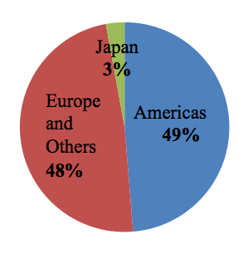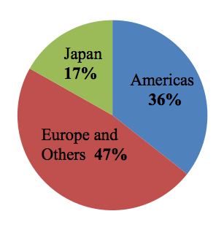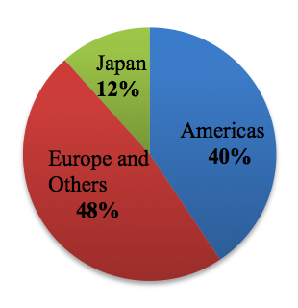
Supply Chain. The following diagram is the supply chain for video game systems. In a sense vertical integration exists in this industry because the three video game competitors fall under two steps in the supply chain: development and design and storage and warehousing as seen in the figure.

Annual Output in Millions or the Three Competitors
Company | 2006 | 2007 | 2008
Nintendo | 30.33m | 45.08m | 59.36m
Sony | 22.28m | 28.73m | 30.75m
Microsoft | 7.47m | 7.93m | 11.37m
Total | 60.08m | 81.74m | 101.48m

Market Value. The market value of the video game console industry has been growing very rapidly and is expected to continue this trend in the future. As of 2005, the estimated market value of the industry was $29 billion. Analysts predict that in 2011, the market value will have grown to $44 billion and will only continue to thrive.

- Industrial Accessories other than Gaming :

The ever growing craze & success of the Gaming Industry has boosted up the Economic growth of the Clothing, Stationary, etc Industries as well.
The T-shirt and School, Colleges Bags use the Gaming fonts and styles of some particularly famous games.

Angry Birds was the overnight success of the Rovio Industry, It not only helped the Gaming Industry to rise up but also shared a major part of the profits made by the clothing Industry.

Here are some examples of the above mentioned examples.





8. Future Gaming Industry (Apple Inc)
We currently are missing opportunities in the video game console market, an industrywhich will hit $70 billion by 2015. A new innovative product that Apple could provide consumers with is the iPlay gaming system. The gaming industry is always expanding and Apple is currently not in this profitable market.
The Apple iPlay is a gaming console which would compete with products such as Sony PlayStation and Microsoft Xbox. The iPlay console connects to iCloud and the App Store to play video games, download new games and compete with other players. The App Store would sell video games that could be downloaded to your iPlay immediately and stored on iCloud. The iPlay system would require no discs to play games and every user will have access to thousands of games instantly. The App Store would act as a medium through which players can compete.The competitive advantage of the iPlay over its competitors is the App Store which will allow users to access purchased games on all Apple devices. The access of games through computer and the iPlay gaming system make this new video game console attractive. The iPlay gaming console will lead Apple in to an industry which has been increasingly growing over the years.
The video game console industry is growing so investment in this sector is important for Apple. The amount of households in the United States that will use a next-generation video game console in 2012 will be around 190 million households. Sixty-five percent of American households play computer or video games and currently Apple does not have a large market share. The primary revenue stream from an investment in the gaming console market would be from console sales and game sales from the AppStore. The entry to this 190 million household market would lead to increased profits in a $70 billion industry.
References:

"Apple and Google Steal Market Share from Video Game Systems | VentureBeat." VentureBeat | Tech. People. Money. Web. 16 Nov. 2011. <http://venturebeat.com/2011/04/15/apple-and-google-steal-market-share-from-video-game-systems/>.
"Video Game Statistics, Industry Figures, and Information - GrabStats.com." GrabStats.com - Directory of Industry Statistics, Facts, Figures, and Information. Web. 16 Nov. 2011. <http://grabstats.com/statcategorymain.asp?StatCatID=13>.

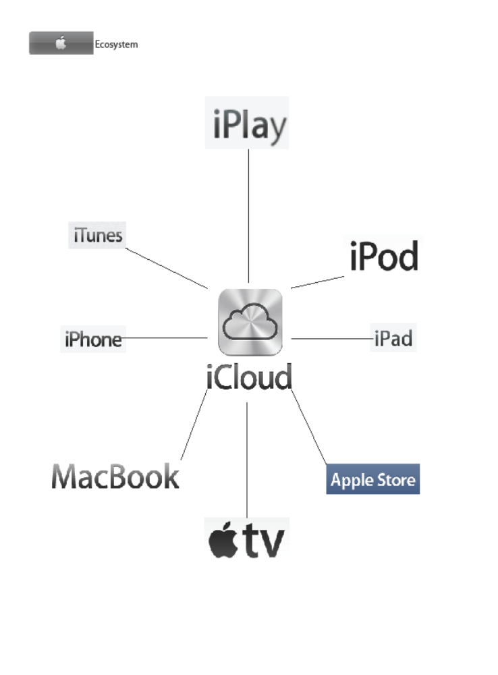

9. Motto
As explained in the Report, Gaming is not only about fun and just a waste of time.
Just as each coin has its two sides, Gaming has its multiple sides from Playing to Learning & from Enjoying to Re-developing yourself.
And that’s our motto as well…

“Learn while you Play”

10. Bibliography :
1. www.google.com/gaming
2.
www.wikipedia.com/video_game_industry
3. www.mob.org/android
4. www.gamesites200.com
5. www.addictinggames.com/india
6. www.xbox360.com/statistics
7. www.sony.com/pspvita
8. www.nintendo.org/wii
9. www.atari.com/playnow.html
10. www.thehindu.com/business_gameindustry
11. www.darshangajara.wordpress.com/category/android/rio_city

